Indian Institute Of Information Technology
Vadodara



Embedded System Project

Group – 9:
Team Members :

- Dheeraj M G | - 202311027

23-03-2026
Today’s Progress – Deep Learning Module

ML(DL) Module Implementation

Collected soil nutrient dataset (N, P, K, pH)
Performed data preprocessing:
- Removed irrelevant columns (District)
- Normalized data using StandardScaler
Created stress classification labels:
- Normal
- Deficient
- Stress
Implemented Parallel CNN-LSTM model
Trained model on dataset
Achieved working prediction output

CNN-LSTM Model for Nutrient Stress Detection

- Input features:
  - Nitrogen (N)
  - Phosphorous (P)
  - Potassium (K)
  - pH
- Model Architecture:
  - CNN → extracts feature relationships
  - LSTM → captures sequential patterns
  - Combined → final classification
- Output:
  - Soil Condition (Normal / Deficient / Stress)

Model Prediction Example
Example Input:
N = 80, P = 40, K = 45, pH = 6.5
Output:
Predicted Soil Condition: Deficient

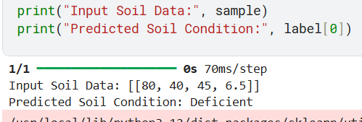

Relation with ACM Research Paper
- Paper uses:
IoT sensors + CNN-LSTM + Bayesian Optimization
- Our implementation:
Embedded system using Arduino
ML prototype using CNN-LSTM
- Difference:
Paper → advanced AI + NPK sensors
Our work → simplified real-time stress detection system
- Future Work:
Integrate IoT + ML model for real-time prediction

